Marko Smiljanic

Facility Escape

CSc 165 – Assignment 3

1. **Marko Smiljanic – Facility Escape**
2. 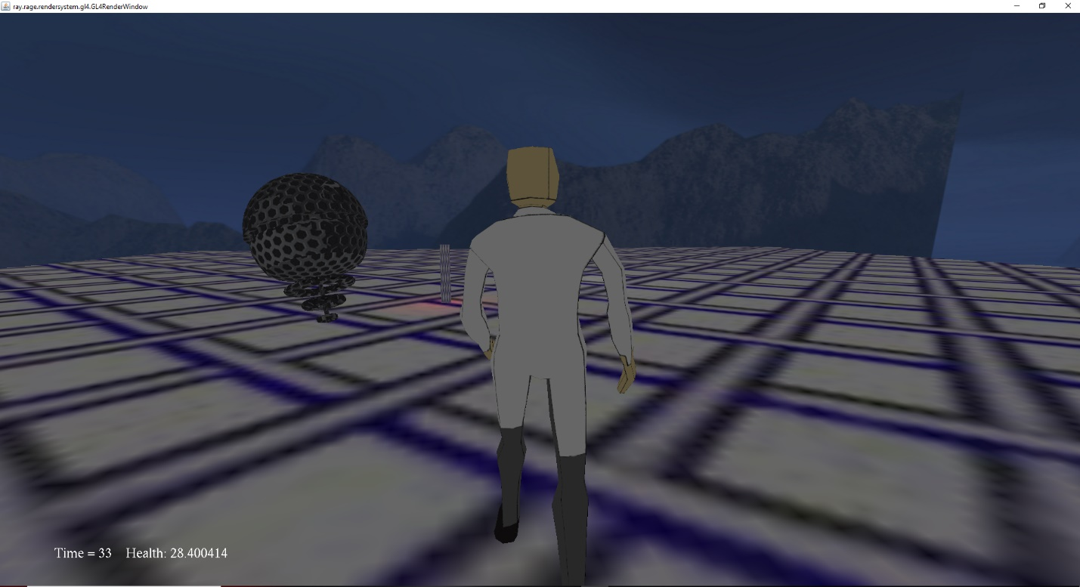 **Game Image**
3. **How to Compile and Run:**

Included in the assignment folder are two batch files, run and runServer. Double runServer.bat to compile and run the server. Now click run.bat to compile and run the client game. This will bring up a command window that will ask for the IP address of the server and the skin you would like your character to show. You can run a second run.bat to use multiplayer. You can also launch the game without a server running and it will work properly.

1. **Special Device Requirements**

This game requires a keyboard and mouse in order to work.

1. **How to Play**

The goal of the game is to hit the button that the robot is guarding. The robot will attack anyone that approaches it and will hurt them if it is near. If you lose all your health, you won’t be able to move anymore. One player can lure the robot away while the other runs in and hits the button. If you hit the button you have completed the game.

1. **Controls**
   1. W – Move the character forward.
   2. A – Move the character left.
   3. S – Move the character back.
   4. D – Move the character right.
   5. E – Hit the button when you are close enough.
   6. Mouse – Look left, right, up, and down.
2. **Scripting**

Only one variable is tracked by scripting, and that is the sensitivity of the mouse.

1. **Game Information**
   1. Genre – Coop Action Game.
   2. Theme – Science Lab.
   3. Dimensionality – 2D character movement in the X and Z direction, 3D movement for the robot.
   4. Activities – Running and Button Pressing.
2. **Game Requirement Satisfied**
   1. The robot chases you at a fast pace and does a lot of damage so you must move quickly to the button and out of the robot’s reach.
   2. Theme – The robot is scientific, and the character textures are for a security guard and a scientist
   3. The character can look around in any direction, but he can only move on the X and Z axis. The robot can also move along the Y axis.
   4. You can run away from the robot and you can press the button to make it turn green.
3. **Requirements Not met**

I was unable to get terrain following, FSEM, and a hierarchical system working in my game.

1. **Techniques Beyond Requirements**

Not that I am aware of.

1. **Team Contributions**

I am the only member and everything that was made, I made for the game.

1. **Items Created**
   1. Meshes used for the avatars and the drone.
   2. The three textures available for the player to choose.
   3. Heightmap for the ground plane.
   4. Skeleton for the avatars.
   5. Animations for the avatars.
2. **Permissions**
   1. "Synth Gliss, A.wav" by InspectorJ (www.jshaw.co.uk) of Freesound.org
3. **Lab Machines**

Pokemon and the computer to the left of it (I did not get the name) were used for testing.